UniSA

COMP 3025 - Computer Game Design Concepts

26 March 2015

Assignment Design Document

# G. Dionysopoulos, J. Hart, L. Magee, G. Markou

This is a design document for a first person shooting game inspired by retro shooting games. It is set in medieval Viking, in which you play as a member of a race of Viking Elves, who go about pillaging and looting. The equipment are based on weapons, armor and mythology from both the real Viking culture and the fantasy Elf lore.

The enemies are demons/demonic creatures. They draw influence from Mayan culture.

In this game, the player reconquers areas taken over by the evil demonic invaders, using deadly melee weapons and powerful magic while being supported by allies they rescue.

# Story/Setting

### Set up

The player is an unnamed Viking soldier, the last survivor of the sudden attack on the city of Giafvaldr[1]. The spirit of Yggdrasil descends upon them and gives them super powers. They decide to take back their homeland from the demonic menace.

### Locations

* Fields between cities
* Cities and strongholds within
  + The rural city of Giafvaldr
  + The stronghold city of Yngarsen
  + The opulent city of Reginleiv
* Demon world?

### Finale

The player takes back the regional capital of Sturlusven. A portal opens and they enter it, and come out in the demon world. With their allies in tow, they take over the four demonic sigils present in a demon stronghold. Finally, they reach the fifth and final sigil, which is guarded by a Great Demon. The player defeats the demon and absorbs the power of the sigil. The portal closes and the player comes out, triumphant. Peace is restored, but there are more demons across the county. The five sigils transform into a gigantic minigun and the player runs off into the sunset.

**Update**

One map to correspond with each mode:

A castle stronghold for arena mode

A vast beach land for conquest mode

# Visuals

The visuals of this game are based off the graphics of classic first-person shooters, like DOOM and Shadow Warrior – relatively simple 3D areas filled with 2D billboard objects that always face the player to give the illusion of 3D. However, we've decided to fully implement 3D models to represent actors as it will be easier to implement in Unreal Engine 4, being a 3D engine.

The picture to the right is of the original Shadow Warrior.

## Game Modes

### Campaign

The first mode is a traditional Campaign mode, wherein the player goes through a series of different levels in a linear order. Each level is a large map, divided into segments, each of which must be separately “captured” by the player to progress and complete the stage. Capturing an area involves entering an enemy Point of Importance and defeating all the enemies inside. When a point is captured, a NPC ally will follow the player around afterward and help them. The player has a limited ability to command their allies around.

**Update**

The are no longer any NPC allies and the point of importance is represented by a big tree which can be captured by being attacked until it shines. Objective remains the same which is to capture all Trees.

### Horde

The second mode is a multiplayer free-for-all mode, where up to four players are placed in a single large map. Groups of enemies will spawn and attack the players, and after the last group is defeated, or after a certain period of time, another group will spawn more difficult (or more numerous) than the last. The goal of the player(s) is to survive until the final wave without dying.

**Update**

There is no multiplayer and the enemies spawn constantly the aim is to get a high score.

## Gameplay

We have chosen to use traditional First Person Shooter controls:

For players on a standard computer, the player can input commands using a keyboard and mouse. Movement is controlled using the WASD keys. They can turn and direct the camera using the mouse, and clicking with the mouse will attack any enemy directly in front of him within range. The left and right buttons of the mouse will, depending on the weapon, perform different types of attacks or functions.

Certain wide-swinging weapons such as a great sword can attack multiple enemies in an arc.

Enemies' limbs can be destroyed if the player aims for certain areas.

Allies will help the player by shooting enemies, or providing him with health / resources.

Weapons come in a wide variety, condensed to three types:

* Physical  
  Battle axe, which can cleave through multiple enemies. Has slow attack speed.  
  Sword, which attacks fast but only hits a single enemy.

**Update**

There is only a punch.

* Ranged  
  Crossbow, which has a long reload time but can fire many shots in quick succession.  
  Throwing axe, which flies around in an arc.

**Update**

There is no ranged.

* Magical  
  Ice, which surrounds the player in a circular AoE.  
  Fire, which acts as a flamethrower.

**Update**

There is no ice instead there is lightning.

# Artificial Intelligence

Enemies patrol along predefined paths. Upon seeing the player they’ll attack depending on their type.

* Melee enemies will charge at the player, and stop to attack.
* Ranged enemies will pause (take aim), fire, and then dodge.
* Large enemies will charge at the player, attack while moving, and stop to taunt.

Allies follow the player around staying in fairly close range to them. They will fire at enemies (as they are all ranged) and, if the player is hurt, give them a health restoration item.

**Update**

No melee enemies and Large enemies don’t taunt.

### The Enemy Blueprint

The Enemy Blueprint will be based off the Character Blueprint which comes with a capsule collider for collision with our weapons/bullets which we can change this to a mesh collider for simplicity and assumingly determine which limb was hit by the model or we can add additional colliders appropriate for each enemy.

The character blueprint also includes what is called a CharacterMovementController which handles basic movement functions such as moving, pathfinding, braking, air control, gravity, jumping etc. An arrow object not visible in game (but can be enabled) in order to help tell the direction of the character. It also includes a mesh which is suitable for a 3D Character.

The bullets will most likely be done with ray tracing as the bullets are going to be too fast to collide with the capsule.

We will attempt to program the entire game within Unreals' Editors, and try to avoid C++ unless it is either a) much easier or b) only possible in C++.

### The Ally Blueprint

The Ally Blueprint will also be based off the Character Blueprint and be similar to Enemy Blueprint. The main difference is that they are enemies of the "Enemy" and be selected for target using some algorithm to determine who to attack. Similar with allies choosing what enemies to attack.

# Map Specifications

### Campaign Maps

The levels of the game are set in large enclosed areas. Each area is divided into a number of sections, and each section is filled with enemies the player must defeat. 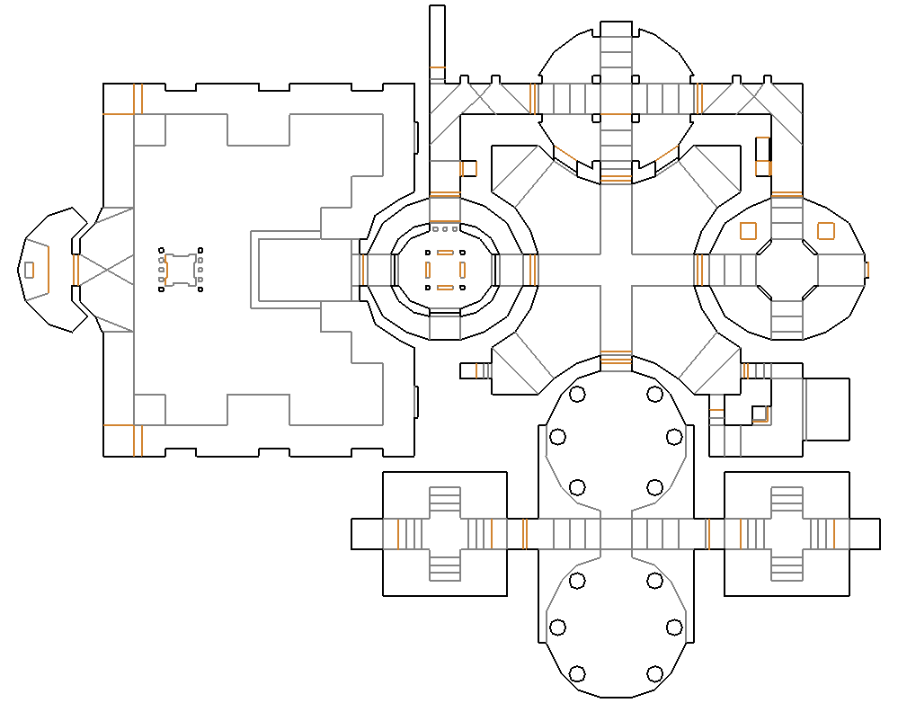This example map, from DOOM 2, demonstrates the kind of areas we want to have.

# Enemy Types

Through the course of the game the player will encounter various types of enemies in their path, designed to provide varied, fun obstacles for them to overcome.

### Generic Demon

Health Pool: Small

Damage: Low

Attributes: Patrol in large amounts. They are melee-type enemies and will swarm at the player to attempt to overwhelm them.

Vulnerability: Cleaving-type weapons like the Battle Axe and Flamethrower.

### Commander

Health Pool: Medium

Damage: Medium

Attributes: Ranged enemy with melee attacks. They launch missiles at the player when distant.

Vulnerability: Direct damage weapons like the Straight Sword and Crossbow

### Summoner A

Health Pool: Medium

Damage: None

Attributes: Summons 4-6 Floating Demon As that protect it from the player, but is otherwise defenseless.

Vulnerability: Any.

### Floating Demon A

Health Pool: Low

Damage: Medium

Attributes: Flies over to player and circles them, diving at them from time to time.

Vulnerability: Cleaving-type weapons like the Battle Axe and Flamethrower.

### Summoner B

Health Pool: Medium

Damage: None

Attributes: Summons 4-6 Floating Demon Bs that protect it from the player, but is otherwise defenseless.

Vulnerability: Any.

### Floating Demon B

Health Pool: Low

Damage: Medium

Attributes: Charges at player. Explodes on impact with player or upon damage received.

Vulnerability: Ranged weapons.

### Berserker

Health Pool: High

Damage: High

Attributes: Charges at player. Has powerful, but delayed attacks.

Vulnerability: Dodging attacks quickly.

### Knight Demon (Boss)

Health Pool: High

Damage: High

Attributes: Has a sword and attempts to charge and slash at the player. Grants the Straight Sword weapon when defeated.

### Master Demon (Boss)

Health Pool: Very High

Damage: High

Attributes:

**Update**

We have a spider demon, imp demon, floating demon, and Boss demon.

1. http://fantasynamegenerators.com/viking_names.php